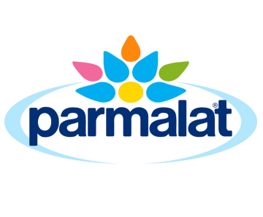

Quality Policy

Parmalat is committed to the supply of legal, safe and quality products which comply with customer expectation, by developing and maintaining management systems capable of meeting these responsibilities.

Parmalat is committed to:

- Maintaining compliance to Export Control (Milk and Milk Products) Orders 2005, Food Standards Codes (FSANZ), BRC Global Standard for Food Safety, relevant Customer Standards (eg, WSEP, CFMSR, Aldi QASR, McDonalds SQMS), SQF Level 3, FSSC 22000, ISO 22000, State Dairy or Food Authority and all other relevant contractual, regulatory and legislative requirements

- Ensuring that each manufacturing site is kept informed of scientific and technical developments, industry codes of practice and all relevant legislation
- Recognising that food safety is a cross-functional responsibility that includes activities by many departments using HACCP principles in our food manufacturing operations, to produce and supply safe products for consumption

- Requiring Managers and supervisory team members to show leadership and responsibility in all activities

- Monitoring, reviewing and continually improving quality outcomes by setting quality objectives and targets in relation to the company’s overall performance

- Supplying and maintaining adequate resources, including personnel and financial resources to ensure that the requirements of this policy can be met at all times

- Working actively with our suppliers of goods and services to seek ways to promote continuous improvement in the quality of our products

- Ensuring employees are aware of their responsibilities by providing them with the training and resources required to produce quality products

- Having open and honest communications at all times with all relevant stakeholders related to the manufacture of quality products

Ron Grantham _______________
General Manager Industrial Site Manager
Parmalat Australia Pty Ltd

