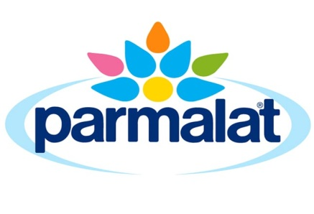

ALLERGEN POLICY

The safety, wholesomeness and nutritional value of our products are of paramount importance to Parmalat and are emphasised in the company Quality Policy. Our policy is to be in complete compliance with National and State Health Department Food Standards.

In relation to allergenic materials, the Parmalat policy is to ensure that there is clear labelling, in compliance with Standard 1.2.3 of the Australia and New Zealand Food Standards Code, when allergens identified in the Code are present in our products.

The VITAL risk assessment tool is used to determine any potential cross contact risk that exists during the manufacturing of Parmalat dairy products. The risk assessment tool takes into consideration the raw materials, the processing, the cleaning and how these contribute to the final finished product. It is part of the Hazard Analysis and Critical Control Point process and has been validated by independent testing.

Accordingly, we require warranties from all our suppliers concerning the allergen status of ingredients and additives.

Our business is based on respect for our consumers and their diverse needs and preferences. Our policies and procedures are designed to reflect this.

Ron Grantham
General Manager Industrial
Parmalat Australia Pty Ltd

10 January 2019

For more information please contact our Consumer Information Centre on
Free Call 1800 676 961.

