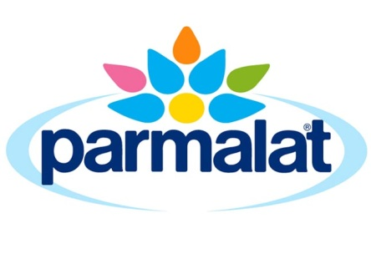

Policy on Genetically Modified Foods

The safety, wholesomeness and nutritional value of our products are of paramount importance to Parmalat and are emphasised in the company Quality Policy. Our policy is to be in complete compliance with National, State and Territory Food Standards.

In relation to genetically engineered or genetically modified (GE/GM) materials, Parmalat’s policy is to avoid their use whenever possible.

Accordingly, we require from all our suppliers, warranties in regard to the GE/GM status of ingredients and additives.

Ingredients | All ingredients including fruit juices and other non-soy based ingredients are non-GE/GM.
Parmalat Milk Supply | Our preference is that farmers supplying milk direct to Parmalat avoid GE/GM feed for their cows and the Parmalat farm quality system requires that they seek warranties from their suppliers of compounded feeds when in doubt.
3rd Party Milk Supply  Milk Ingredients  Contract Packing | Each business partner warrants that the overall stock feed ration used on their supplier’s farms is either non-GE/GM or would contain only insignificant levels.
Soy | Soy beans used are from non-GE/GM soy beans controlled under a strict “Identity Preservation” system. Our soy bean suppliers have warranted to contain any inadvertent trace contamination to an absolute minimum. Other ingredients used in our soy products are non-GE/GM.

Our business is based on respect for our consumers and their diverse views and preferences. Our policies and procedures are designed to reflect this.
Ron Grantham
General Manager Industrial
Parmalat Australia Pty Ltd
10 January 2019

For more information please contact our Consumer Information Centre on
Free Call 1800 676 961

